Lagged cross-correlation: GBPUSD and AUDUSD
Method 12 / daily log returns / K_max=10 / Alpari D1 full available history

Study setup
Logical pair: GBPUSD , AUDUSD
Broker symbols: GBPUSD_i , AUDUSD_i
Snapshot: 2026-11-03_majors_alpari_D1
Timeframe: D1
Matched return window: 1999-01-05 to 2026-11-02 (UTC bar dates)
Matched return count n: 7228
Dropped unfinished last bar dated 2026-11-03 UTC after a tick-volume check against the prior complete day.
Lag definition: rho_X->Y(k) = Corr(x_t, y_{t+k}) on matched D1 bars
K_max = 10; headline lag k = 1 (both directions)
Complete matched rows (Excel): GBPUSD-AUDUSD_Lagged_D1.xlsx
Complete matched rows (HTML table): GBPUSD-AUDUSD_Lagged_D1_data.html

Method carried forward
Lagged cross-correlation measures Pearson correlation between matched daily log returns of close, ln(close_t / close_t-1), after shifting one series forward by k bars on the matched panel. Quotes are not inverted. rho_{X->Y}(k) = Corr(x_t, y_{t+k}) with n_k = n - k. K_max = 10 is fixed before estimation. The headline is the pre-specified lag k = 1 in both directions. k = 0 is the same-bar side check. The lag inside 1..10 with the largest absolute rho is stored as a descriptive column only; it is not a selected result. This is a linear screen, not proof of forecast edge, economic cause, or a trading signal.

Results (headline k=1)
rho_GBPUSD->AUDUSD(1): -0.029977 (n=7227)
95% Fisher interval GBPUSD->AUDUSD: [-0.052996, -0.006926]
rho_AUDUSD->GBPUSD(1): 0.019983 (n=7227)
95% Fisher interval AUDUSD->GBPUSD: [-0.003074, 0.043019]
Same-bar rho(k=0): 0.539048
Largest |rho| among k=1..10 (descriptive only, not selected): GBPUSD->AUDUSD k=6 rho=-0.035810; AUDUSD->GBPUSD k=8 rho=0.039877

CCF table
k | rho_GBPUSD_to_AUDUSD | n_GBPUSD_to_AUDUSD | rho_AUDUSD_to_GBPUSD | n_AUDUSD_to_GBPUSD
0 | 0.53904795 | 7228 | 0.53904795 | 7228
1 | -0.02997667 | 7227 | 0.01998324 | 7227
2 | 0.00089946 | 7226 | 0.00042561 | 7226
3 | 0.00601004 | 7225 | -0.01292949 | 7225
4 | 0.01379019 | 7224 | 0.00788275 | 7224
5 | -0.02290785 | 7223 | -2.316e-05 | 7223
6 | -0.03580994 | 7222 | -0.01690579 | 7222
7 | -0.00745091 | 7221 | 0.00651883 | 7221
8 | -0.00362758 | 7220 | 0.03987728 | 7220
9 | -0.00658862 | 7219 | -0.02231209 | 7219
10 | -0.03199736 | 7218 | -0.00085849 | 7218

Conclusion
At the pre-specified lag k=1 for GBPUSD and AUDUSD, rho_{GBPUSD->AUDUSD}(1) = -0.0300 (n=7227) and rho_{AUDUSD->GBPUSD}(1) = 0.0200 (n=7227). Same-bar rho(k=0) = 0.5390. Largest |rho| among k=1..10 is descriptive only: GBPUSD->AUDUSD at k=6 (-0.0358); AUDUSD->GBPUSD at k=8 (0.0399). This is a linear screen, not forecast proof or a trading signal.

Charts
Daily closes

Daily log returns

CCF both directions k=0..10
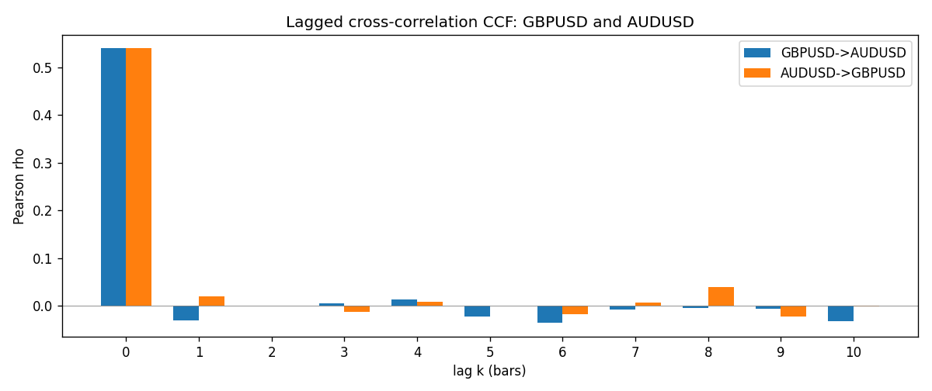

Data report
Every matched row is stored in the sibling Excel workbook named GBPUSD-AUDUSD_Lagged_D1.xlsx (sheet matched_rows). The CCF sheet holds rho(k) for k=0..10. Embedding all rows as a Word table is impractical; the Word file holds column summaries and the first and last 15 rows.
Columns: time, GBPUSD_open, AUDUSD_open, GBPUSD_high, AUDUSD_high, GBPUSD_low, AUDUSD_low, GBPUSD_close, AUDUSD_close, GBPUSD_tick_volume, AUDUSD_tick_volume, GBPUSD_spread, AUDUSD_spread, GBPUSD_real_volume, AUDUSD_real_volume, GBPUSD_log_return, AUDUSD_log_return
Column summaries (matched calculation rows)
column | count | mean | std | min | 25% | 50% | 75% | max
GBPUSD_open | 7228 | 1.5166822 | 0.21834818 | 1.06854 | 1.3254025 | 1.51196 | 1.63237 | 2.1066
AUDUSD_open | 7228 | 0.75192541 | 0.13534725 | 0.4785 | 0.66102 | 0.7315 | 0.8091975 | 1.10284
GBPUSD_high | 7228 | 1.5229801 | 0.21891417 | 1.08366 | 1.3300275 | 1.518725 | 1.638825 | 2.1161
AUDUSD_high | 7228 | 0.75597511 | 0.13590934 | 0.4878 | 0.664695 | 0.734945 | 0.81552 | 1.10795
GBPUSD_low | 7228 | 1.5103473 | 0.21757706 | 1.03518 | 1.32009 | 1.50469 | 1.624985 | 2.0983
AUDUSD_low | 7228 | 0.74786335 | 0.13465689 | 0.4775 | 0.6577 | 0.72762 | 0.804475 | 1.0975
GBPUSD_close | 7228 | 1.5167386 | 0.2183035 | 1.06879 | 1.32568 | 1.51203 | 1.6324775 | 2.1065
AUDUSD_close | 7228 | 0.75196864 | 0.13532707 | 0.4786 | 0.6611875 | 0.731775 | 0.809315 | 1.10169
GBPUSD_tick_volume | 7228 | 94565.268 | 153330.81 | 62 | 9974.5 | 52775.5 | 91622.5 | 1273370
AUDUSD_tick_volume | 7228 | 77126.179 | 137934.11 | 109 | 5406 | 43250.5 | 71246.75 | 1234623
GBPUSD_spread | 7228 | 27.003182 | 19.183813 | 0 | 11 | 20 | 50 | 50
AUDUSD_spread | 7228 | 30.855562 | 16.875394 | 0 | 13 | 30 | 50 | 50
GBPUSD_real_volume | 7228 | 3.5428062e+09 | 8.4280615e+10 | 0 | 0 | 0 | 0 | 2.4038164e+12
AUDUSD_real_volume | 7228 | 5.2225089e+09 | 1.2514647e+11 | 0 | 0 | 0 | 0 | 3.811512e+12
GBPUSD_log_return | 7228 | -2.954e-05 | 0.0056473 | -0.08388241 | -0.00313242 | 3.002e-05 | 0.00317333 | 0.03112653
AUDUSD_log_return | 7228 | 1.629e-05 | 0.00754363 | -0.08602525 | -0.00386494 | 0.00027649 | 0.00415111 | 0.0806166
First 15 matched rows (selected columns)
time | GBPUSD_close | AUDUSD_close | GBPUSD_log_return | AUDUSD_log_return
1999-01-05 | 1.6547 | 0.6215 | -0.0028966287 | -0.00080418179
1999-01-06 | 1.6537 | 0.6289 | -0.00060452184 | 0.011836351
1999-01-07 | 1.6502 | 0.6345 | -0.002118709 | 0.0088650256
1999-01-08 | 1.6405 | 0.6347 | -0.0058954193 | 0.00031515916
1999-01-11 | 1.6312 | 0.6393 | -0.0056851331 | 0.0072213815
1999-01-12 | 1.6349 | 0.6362 | 0.0022657001 | -0.0048608485
1999-01-13 | 1.6499 | 0.6312 | 0.0091330396 | -0.0078902098
1999-01-14 | 1.6531 | 0.6295 | 0.0019376331 | -0.002696916
1999-01-15 | 1.6502 | 0.634 | -0.0017558204 | 0.007123101
1999-01-18 | 1.6522 | 0.6346 | 0.0012112405 | 0.00094592471
1999-01-19 | 1.6553 | 0.6392 | 0.0018745281 | 0.0072225153
1999-01-20 | 1.6472 | 0.64 | -0.0049053846 | 0.0012507819
1999-01-21 | 1.6524 | 0.6405 | 0.0031518998 | 0.00078094498
1999-01-22 | 1.6565 | 0.6327 | 0.0024781662 | -0.012252745
1999-01-25 | 1.6585 | 0.6302 | 0.0012066366 | -0.0039591468
Last 15 matched rows (selected columns)
time | GBPUSD_close | AUDUSD_close | GBPUSD_log_return | AUDUSD_log_return
2026-10-13 | 1.32534 | 0.69821 | 0.0036434319 | 0.0035007712
2026-10-14 | 1.31884 | 0.69715 | -0.0049164679 | -0.0015193215
2026-10-15 | 1.32757 | 0.69191 | 0.0065976411 | -0.0075447063
2026-10-16 | 1.33257 | 0.69426 | 0.0037592051 | 0.0033906408
2026-10-19 | 1.33024 | 0.6978 | -0.0017500314 | 0.0050859986
2026-10-20 | 1.3377 | 0.70022 | 0.0055923442 | 0.0034620426
2026-10-21 | 1.33937 | 0.70275 | 0.0012476328 | 0.0036066384
2026-10-22 | 1.33967 | 0.70186 | 0.00022396082 | -0.0012672558
2026-10-23 | 1.33684 | 0.70353 | -0.0021146949 | 0.0023765656
2026-10-26 | 1.33359 | 0.70128 | -0.0024340661 | -0.0032032829
2026-10-27 | 1.33044 | 0.70245 | -0.0023648393 | 0.0016669876
2026-10-28 | 1.33254 | 0.70533 | 0.0015771808 | 0.0040915541
2026-10-29 | 1.33733 | 0.70245 | 0.0035881935 | -0.0040915541
2026-10-30 | 1.33913 | 0.70316 | 0.0013450605 | 0.0010102376
2026-11-02 | 1.3406 | 0.69971 | 0.0010971256 | -0.0049184984

